## Overview

It’s time for you to say “Hello, World…again!” This time, however, you will use JavaScript.

In this activity, you will add code to the index.js located in the Activities folder to display the “Hello, World!” message in your browser’s console.

## Tips

The console.log() function is a valuable tool to troubleshoot your code or log messages when an action happens on a website (e.g., a button was clicked or a form was completed).

The <script> tag is used to define a client-side script (on the user’s computer, in JavaScript) that will run on your webpage.

## Instructions

**Step 1: Link Your HTML and JavaScript Files Together**

1. Open index.html located within the .zip file in the Activities folder.
2. Add a <script> tag within the <body> tag.
3. Next, add an src attribute to your new <script> tag, and set its value to “js/index.js.”
   * **Tip:** Script tag documentation – <https://www.w3schools.com/tags/tag_script.asp>
   * The script tag should look familiar, as it is similar to using the <img> tag to display an image or the <link> tag to link to a CSS file.
4. Notice that you can now use the code located in index.js within index.html. Without linking your index.html and index.js files together, changes you make to your index.js file won’t have any effect on your html.
5. Save your changes before continuing.

**Step 2: Add JavaScript**

1. Open index.js located within the .zip file in the Activities folder.
2. Create a variable named helloWorld and set its value equal to the text string 'Hello World!'.
   * **Tip:** Variable Documentation <https://www.w3schools.com/js/js_variables.asp>
   * Use the var keyword, followed by the variable name, the variable’s value, and a semicolon. The semicolon is not necessary, but it is recommended to indicate the end of a line of code.

| var myFirstVariable = 'variableValue'; |
| --- |

* + **Notes:** 
    - In the example above, the variable myFirstVariable has the value of 'variableValue'.
    - You can set JavaScript variables equal to almost anything, but you will be dealing with text strings and numbers in this class.

1. Next, use the console.log() function to output the helloWorld variable to your browser’s console.
   * **Remember:** A function is a reusable block of code that returns a value (that value can be reused in your code in another function and so on).
   * **Note:** JavaScript has many built-in functions that allow you to manipulate code in any way imaginable.
   * **Tip:** console.log() is one of those built-in functions. It will output a value (a variable, number, text string, etc.) to your browser’s console to display messages to users (or yourself!).
   * The syntax for console.log() is as follows:

| console.log(pizza); |
| --- |

* + **Note:** In the above illustration, the console.log() function will output the pizza variable to your browser’s console.

1. Save your changes in index.js.
2. Open index.html in your browser, and open the Console tab in your browser’s inspector.
3. You should now see a message like the one illustrated below in your console:

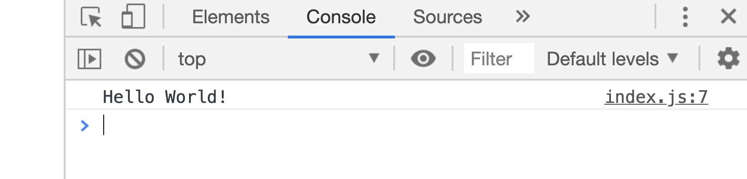

That’s it. Great job!

## 